



CAE Java –

Machine Problem

Delivery Guidelines

Billing Automated

Requisition Service

(BARS)



# Table of Contents

Table of Contents 2

Revision History 3

1. Naming Conventions 4

2. Test Files 4

3. Required Deliverables 5

4. Functional Test Plan (FTP) Results 6

5. SonarQube Results 6

6. Software Metrics 7

7. JUnit Tests 7

# Revision History

|  |  |  |  |
| --- | --- | --- | --- |
| **Version** | **Date** | **Summary** | **Updated By** |
| 2.0 | 3/18/2022 | Update documentation. | Jhayzon Lonn Santos |
|  |  |  |  |
|  |  |  |  |
|  |  |  |  |
|  |  |  |  |
|  |  |  |  |
|  |  |  |  |
|  |  |  |  |
|  |  |  |  |
|  |  |  |  |
|  |  |  |  |
|  |  |  |  |

# Naming Conventions

1. Strictly follow the naming conventions.
   1. Project Name:
      1. *bars-service.<EID>*
      2. Example: **bars-service.juan.dela.cruz**
   2. Database Name:
      1. *bars_db*
   3. Functional Test Plan
      1. Format: *BARS Functional Test Plan v3.0.<EID>*
      2. Example: **BARS Functional Test Plan v3.0.juan.dela.cruz**
   4. Repository (All deliverables are in here – will be uploaded in innersource)
      1. Format: *bars-service.<EID>*
      2. Example: **bars-service.juan.dela.cruz**

# Test Files

A directory that should contain all the test files depending on the scenarios indicated on the FTP and TCER must be created.

* 1. Normal Process
     1. Location: Paste the folder named **BARS_TEST** inside directory C. Download this folder: [BARS_TEST](https://ts.accenture.com/:f:/s/IES-CAE-Java/ErPzIpzyMB5EjEP575U_8aUB8jABiP_4seYT3QgAlhYt9g?e=JxcTQq)

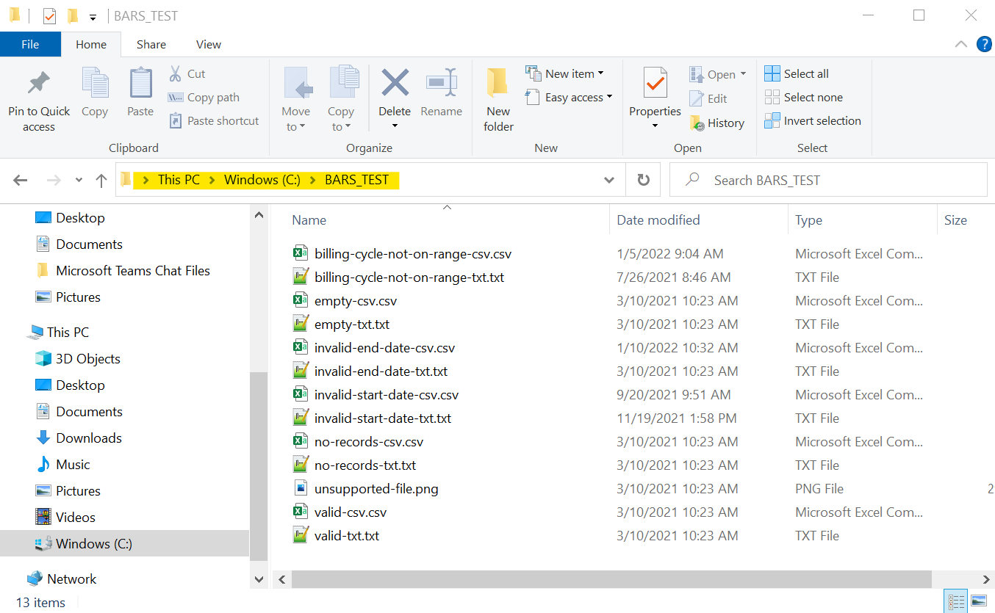

# Required Deliverables

1. 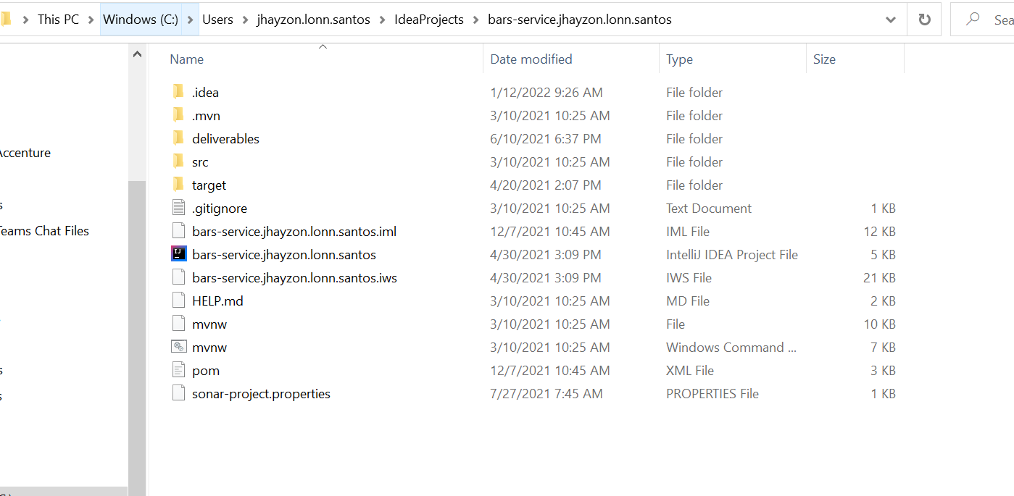**Billing Automated Requisition Service**

Sample Billing Automated Requisition Service project

1. **deliverables –** Contains your Functional Test Plan results and SonarQube results.

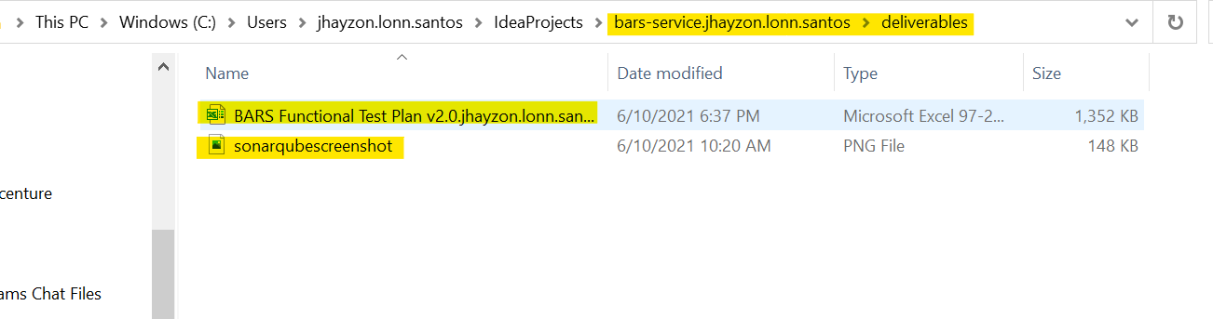

Sample actual files under deliverables folder

# Functional Test Plan (FTP) Results

A peer will be assigned to test your BARS using FTP. This should contain screen shots and actual results. Integrity at all times should be observed.

FTP file can be download at this link: [BARS Functional Test Plan v3.0.eid.xlsx](https://ts.accenture.com/:x:/s/IES-CAE-Java/EUFbsJJ5XgdDnOYATQwZHE0BUJJIcR-15-XQc4eK7NLeWQ?e=svoHFn)

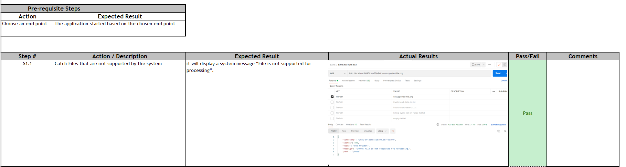

Screenshot from Functional Test Plan, Actual Results must be filled with screenshot of response from postman, Actual result must be matched to expected result to be considered as pass, failed otherwise and comment should be provided for failed results.

# SonarQube Results

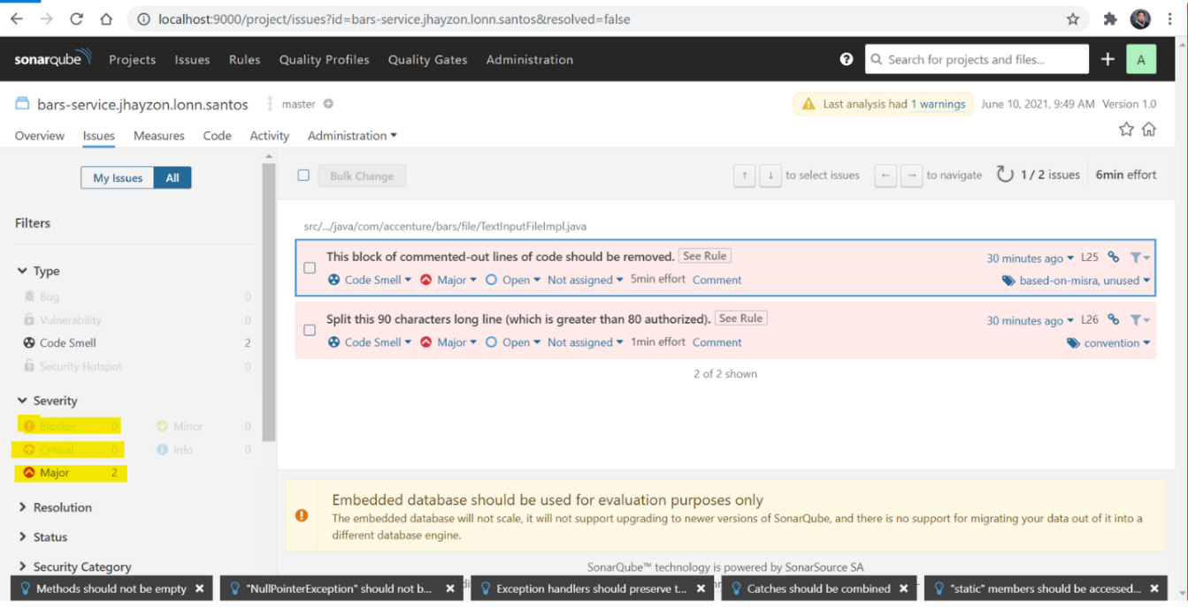Take a screenshot of the Issues tab of your project in SonarQube and save the image to the deliverables folder. Instruction about using SonarQube can be found on this link: [SonarQube Setup.docx](https://ts.accenture.com/:w:/s/IES-CAE-Java/EadzqRVMbo5Ik2KJAFdr71YBYt0t2e7FIEYgeQuvXTpYIg?e=PYoxkJ)

Screenshot from SonarQube Interface showing code smells of your BARS Project

# Software Metrics

The following are the criteria on how your development will be evaluated:

|  |  |
| --- | --- |
| **Criteria** | **Description** |
| Unit Test | Total Unit Passed (Test Methods). Refer to TCERs provided for the complete list of unit tests. |
| Component Test | Total Functional Scenarios Passed. Refer to Functional Test Plan provided for the complete scenarios. |
| Code Quality | Using Sonar, codes should have zero (0) Blocker, zero (0) Critical and zero (0) Major Violations. |

# JUnit Tests

Below are the required test classes that should be created with respect to its implementation. Reference about the JUnit tests can be found on this link:

[BARS Test Conditions and Expected Results (TCER) v2.0.xls](https://ts.accenture.com/:x:/s/IES-CAE-Java/Ea4KojzmNOtAulltjY9eurwBNouoNPSLc8N48MsxKrlUnw?e=hanph7)

|  |
| --- |
| 1. InputFileFactoryTest |
| 2. CSVInputFileImplTest |
| 3. TextInputFileImplTest |